INTERNSHIP REPORT



DEPARTMENT OF

COMPUTER ENGINEERING

PCET’s Pimpri Chinchwad College of Engineering, Pune

Internship report of work in **JSW Steel Ltd. Dolvi Works** done by

**Gaurang Sandeep Shende**

**PRN: 123B1B033**

During the period of 1st December 2025 – 1st January 2026 under the guidance of

**Mr. M V Raman**

**(HOD IT Department**

**JSW Steel Ltd. Dolvi Works)**

Date: 30/12/2025

**Department of Information Technology**

**JSW STEEL Ltd. DOLVI WORKS**

**Dolvi, Pen – 402107**

**AN INTERNSHIP REPORT ON**

**“JSW Slab Allocation System”**

SUBMITTED TO THE PIMPRI CHINCHWAD COLLEGE OF ENGINEERING, PUNE

IN THE PARTIAL FULFILLMENT OF THE REQUIREMENTS

FOR THE COURSE INTERNSHIP

OF

**BACHELOR OF ENGINEERING**

**(COMPUTER ENGINEERING)**

##### SUBMITTED BY

**Gaurang Sandeep Shende**

**PRN: 123B1B033**

**

## DEPARTMENT OF COMPUTER ENGINEERING

## PCET’S PIMPRI CHINCHWAD COLLEGE OF ENGINEERING,

**NIGDI, PUNE 411044**

## (Academic Year 2025-26)



**CERTIFICATE**

This is to certify that **Gaurang Sandeep Shende PRN: 123B1B033** has successfully completed his internship work on **“JSW Slab Allocation System”** at “**JSW Steel Ltd. Dolvi Works, Vadkhal, Dolvi, Pen - 402107”** during the “**1st Dec 2025 – 1st Jan 2026”** in partial fulfillment for the award of the **Engineering Degree in Computer Engineering**.

|  |  |
| --- | --- |
|  |  |
| **Name of Faculty Mentor** | **Head, Department of Computer Engineering** |

Date:

|  |  |  |
| --- | --- | --- |
| **SR. NO.** | **TITLE** | **Page No.** |
| 1 | Overview of Company | 1 |
| 2 | Introduction | 3 |
| 3 | Internship Discussion | 6 |
| 3.1 | Project Description | 6 |
| 3.2 | Learning Experience | 7 |
| 3.3 | Knowledge Acquired | 7 |
| 3.4 | Skills Learned | 8 |
| 3.5 | Observed Attitudes and Values | 8 |
| 3.6 | Most Challenging Task Performed | 8 |
| 4 | Results | 9 |
| 5 | Conclusion | 12 |
| 6 | Bibliography | 13 |
| 7 | Plagiarism Report | 14 |

1. **Overview of Company**

Based in Mumbai, Maharashtra, JSW Steel Ltd. is an Indian steel manufacturer. It is a JSW Group subsidiary. With a presence in more than 140 countries, it is among the fastest-growing businesses in India. Based in Mumbai, Maharashtra, India, JSW Steel is a steel company owned by the JSW Group. Following its merger with ISPAT Steel, JSW Steel is now the second-biggest private sector steel company in India. 18 MTPA is the installed capacity as of right now. The JSW Group is a $13 billion conglomerate that operates in India, the United States, South America, and Africa. It is a member of the O.P. Jindal Group and has a significant presence in several key economic sectors, including steel, energy, infrastructure, cement, ventures, and sports.

**History:**

JSW Steel's history can be traced back to 1982, when the Jindal Group acquired Piramal Steel Limited, which operated a mini steel mill at Tarapur in Maharashtra and renamed it as Jindal Iron and Steel Company (JISCO). Soon after the acquisition the group set up its first steel plant in 1982 at Vasind, near Mumbai.

Later, in 1994, Jindal Vijayanagar Steel Limited (JVSL) was set up with its plant located at Toranagallu in the Bellary-Hospet area in the State of Karnataka, the heart of the iron ore belt and spread over 10,000 acres (40 km2) of land. It is well connected to both the Mormugao Port and Chennai Port and is 340 kms from Bangalore. It is said to be the sixth largest steel plant in the world.

In the year 2005, JISCO and JVSL merged to form JSW Steel Limited. It also set up a plant at Salem with an annual capacity of 1 million tonnes.

**Operations:**

As of July 2023, the installed with a production capacity of 29.7 MTPA in India and the United States. By the year 2025, the company hopes to increase its overall steel production capacity to 38.5 MTPA. As of April 2023, steel and related products—long rolled products (18%), galvanized coils/sheets (15%), CR coils/sheets (9%), plates/pipes (5%), other miscellaneous steel products (5%), and iron ore (2%), in that order—account for nearly 98% of JSW Steel's revenue. India accounts for 70% of total revenue, with the remaining 30% coming from outside the country. Due to its beginnings in a cold rolling mill, the company has historically placed a strong focus on flat products. The company usually sends half of its flat products to downstream facilities for additional value-enhancing processes like galvanizing, coating, or tinning as part of its corporate strategy.

**Plants:**

**JSW Dolvi Works:** The company paid $3 billion to acquire JSW Dolvi Works, also known as Integrated Steel Plant, Dolvi, from Ispat Steel in 2010. It was the first steel plant in India to use ConArc technology for both producing compact strips and steel. ConArc uses iron pellets, which are basically one-step processed iron ore, while a blast furnace turns iron ore into steel. The Central Industrial Security Force granted Dolvi Works security protection in 2022. It was the thirteenth private sector industrial facility in India to be under CISF security at that time.

**JSW Vijayanagar Works:** Integrated Steel Plant, Vijayanagar, or JSW Vijayanagar Works: It is the company's flagship plant and the biggest single-location steel manufacturing facility in India. The plant is currently undergoing a brownfield expansion with the goal of raising its capacity from 13 MTPA to 18 MTPA by FY24. A 4.5 MTPA blast furnace, two 350-ton steel melt shops, a 5 MTPA hot strip mill, and several other associated facilities will be added to this 600-acre expansion. As part of a new waste disposal and environmental strategy, Vijayanagar Works implemented a new ladle furnace slag recycling procedure in 2017–2018. The report emphasized cutting back on the use of particular synthetic slag.

**JSW Sambalpur Works:** The company purchased JSW Sambalpur Works (also called Integrated Steel Plant, Rengali) in 2019 following the National Company Law Tribunal's liquidation of Bhushan Power & Steel. It increased the company's total steel production capacity by 3.5 MTPA.

**JSW Salav Works:** In 2014, JSW Steel paid ₹1,000 crore (US$130 million) to acquire this plant, which had previously belonged to Welspun Group. It is situated close to the JSW Dolvi Works—within 40 kilometers.

The first coated steel plant in India, JSW Kalmeshwar Works, produces galvanized, galvalume, and pre-painted galvanized/galvalume steel. The plant, located 30 kilometers from Nagpur in Central India, was purchased by the company from Ispat Steel.

**JSW Tarapur Works:** The largest single-location coated steel plant in the nation, JSW Tarapur Works produces ultrathin coated goods like pre-painted galvanized/galvalume steel, galvanized, and bare galvalume steel. Mumbai is approximately 100 kilometers away. JSW Vasind Works is a complex with cold rolling, galvanizing, and color coating capabilities that is located 70 kilometers from Mumbai.

**JSW Salem Works:** Known for producing special alloy steel, the plant is 350 kilometers from Chennai.

## INTRODUCTION

One of the top producers of steel in India, JSW Steel Ltd. has a significant market share both domestically and abroad. It is a flagship company of the JSW Group and contributes significantly to the nation's industrial growth and infrastructure development. JSW Steel is renowned for its dedication to quality, ongoing innovation, and the use of cutting-edge technologies to improve operational effectiveness and sustainability in the steel industry.

The Information Technology (IT) department at JSW Dolvi Works plays a crucial role in enabling these digital initiatives. It supports core plant operations by developing and maintaining software systems that assist in production monitoring, material tracking, decision support, and enterprise integration. The IT department acts as a bridge between industrial processes and information systems, ensuring that accurate and timely data is available for effective planning and control.

I, Gaurang Sandeep Shende, completed my internship at JSW Steel Ltd., Dolvi Works, during the period from 1st December 2025 to 1st January 2026 under the guidance of professionals from the IT Department. This internship provided me with valuable exposure to a real industrial environment, where I could observe how large-scale manufacturing operations are managed using technology and data-driven methodologies.

The internship offered hands-on experience with real-world industrial data and operational challenges, allowing me to apply computer engineering concepts such as programming, data analysis, and system design in a practical setting. It helped me understand the importance of accuracy, efficiency, and reliability in industrial applications, while also strengthening my technical foundation and professional skills.

### Abstract

The rapid growth of data-driven decision-making in the manufacturing sector has created a need for intelligent systems that can improve operational efficiency and resource utilization. In steel industries, efficient allocation of slabs to customer orders is a critical task, as improper allocation can lead to material wastage, increased leftovers, and delays in order fulfillment. This internship project focuses on the design and development of a JSW Slab Allocation System to automate and optimize the process of slab allocation at JSW Steel Ltd., Dolvi Works.

The proposed system is a web-based application that allocates steel slabs based on customer requirements such as thickness, width, length, grade, and required tonnage. The allocation logic follows a staged approach consisting of exact match allocation, tolerance-based allocation, and nearest-fit allocation to ensure maximum utilization of available inventory while meeting customer specifications. This systematic approach reduces manual effort, minimizes errors, and improves consistency in allocation decisions.

In addition to slab allocation, the system incorporates a sales forecasting module using time series analysis techniques such as ARIMA to predict short-term demand trends based on historical data. The forecasting feature provides valuable insights for production planning and inventory management, enabling better decision-making for future operations.

The application is developed using Python and Streamlit, with data processing performed using libraries such as Pandas and NumPy. The system provides an interactive dashboard displaying allocation summaries, detailed results, and visualizations, along with the ability to export reports for operational use. The project demonstrates the practical application of data analytics and software engineering principles in solving real-world industrial problems, and highlights how automation and predictive analysis can enhance efficiency and productivity in manufacturing environments.

### Scope of Work

The scope of this internship project was focused on understanding the slab allocation process at JSW Steel Ltd., Dolvi Works, and developing a software-based solution to automate and optimize this critical operational activity. The work carried out during the internship covered both analytical and implementation aspects, with emphasis on practical applicability in an industrial environment.

1. **Understanding the Business Process:**

Studying the slab inventory management system, customer order requirements, and the challenges involved in manual or semi-automated slab allocation. This involved understanding how slab dimensions, grades, and tonnage affect allocation decisions.

1. **Data Collection and Pre-processing:**

Analyzing real slab inventory datasets provided during the internship, identifying missing values, inconsistencies, and irrelevant records, and performing data cleaning and pre-processing to make the data suitable for analysis and allocation logic.

1. **Design of Allocation Logic:**

Developing a staged allocation strategy consisting of exact match, tolerance-based matching, and nearest-fit allocation to ensure efficient utilization of slabs while satisfying customer requirements.

1. **System Development:**

Implementing the allocation logic using Python and building an interactive web-based dashboard using Streamlit to allow users to input requirements and view allocation results in real time.

1. **Sales Forecasting:**

Studying historical sales data and implementing time series forecasting techniques such as ARIMA to predict short-term future demand, thereby supporting production planning and inventory decisions.

## INTERNSHIP DISCUSSION

### 3.1 Problem / Project Description

In a large steel manufacturing organization such as JSW Steel Ltd., slabs are produced in significant volumes with varying dimensions and grades based on production schedules and market demand. Each customer order specifies particular requirements in terms of thickness, width, length, grade, and total tonnage. Efficiently allocating the available slabs to these orders is a complex and critical operational task, as it directly impacts material utilization, order fulfilment time, and overall production efficiency.

Traditionally, slab allocation is carried out using manual methods or spreadsheet-based approaches, which require substantial human effort and are prone to errors, especially when dealing with large and continuously changing datasets. Such approaches often result in suboptimal utilization of slabs, increased leftovers, delays in decision-making, and difficulties in maintaining consistency across allocations. These challenges highlight the need for an automated and systematic solution that can assist planners in making accurate and efficient allocation decisions.

The project assigned during the internship aimed to design and develop a **JSW Slab Allocation System**, a software-based application that automates the process of matching customer requirements with available slab inventory. The primary objective of the system is to ensure maximum utilization of slabs while satisfying customer specifications and minimizing material wastage.

The system accepts customer inputs such as thickness, width, length, grade, and required tonnage, and processes real slab inventory data to determine the most suitable slabs for allocation. The allocation logic is designed using a staged approach. In the first stage, the system attempts to allocate slabs that exactly match all specified parameters. If sufficient slabs are not available, the second stage applies tolerance-based allocation, allowing a predefined deviation in dimensions to increase the chances of fulfilling the requirement. In the final stage, the system performs nearest-fit allocation, selecting slabs that are closest to the desired dimensions when exact or tolerance matches are insufficient. This hierarchical strategy ensures both accuracy and flexibility in allocation.

The project also integrates a sales forecasting module that analyzes historical data to predict short-term future demand using time series techniques such as ARIMA. This feature provides additional support for production planning and inventory management by offering insights into expected sales trends.

### 3.2 Learning Experience

The internship at JSW Steel Ltd., Dolvi Works provided valuable exposure to a real industrial environment and helped me understand how information technology supports large-scale manufacturing operations. Working with the IT department allowed me to observe how data-driven systems are used for planning, monitoring, and optimizing processes within the steel plant.

One of the key learning experiences was handling real-world industrial data. The slab inventory datasets contained missing values, inconsistencies, and non-uniform formats, which required careful pre-processing and validation. This helped me realize the importance of data quality and robustness while designing practical software solutions. I also learned how project requirements evolve and how iterative development based on feedback leads to better system design.

In addition to technical learning, the internship enhanced my understanding of professional work culture. Interacting with mentors and team members improved my communication skills, teamwork, and ability to adapt in a professional environment. Overall, the experience strengthened my problem-solving approach and prepared me to apply theoretical knowledge effectively in real-world industrial applications.

#### 3.3 Knowledge Acquired

During the internship, I gained practical knowledge about how industrial data is generated, managed, and used for operational decision-making in a manufacturing environment. I learned how slab inventory data is structured and how such data plays a critical role in planning, allocation, and resource optimization within the steel industry.

The internship helped me apply concepts studied in academic courses such as Data Structures, Database Management Systems, Probability and Statistics, and Machine Learning to a real-world problem. Designing allocation logic strengthened my understanding of logical filtering and searching, while working with historical sales data introduced me to time series analysis and forecasting techniques such as ARIMA.

I also gained domain knowledge related to steel manufacturing processes and operational constraints, which was essential for developing a solution that was practical and relevant. This experience enhanced my analytical thinking and helped me understand how technical knowledge, when combined with domain understanding, can lead to effective industrial solutions.

#### 3.4 Skills Learned

The internship helped me develop strong technical skills, particularly in Python programming and data analysis. I became more proficient in using libraries such as Pandas and NumPy for handling large datasets, filtering records, and implementing rule-based logic for slab allocation. I also gained experience in building simple dashboards using Streamlit to present results interactively.

I improved my problem-solving and debugging skills by testing the system under different scenarios and refining the logic based on observed results. This process enhanced my ability to think logically, break complex problems into smaller parts, and design modular code that is easier to maintain and improve.

#### 3.5 Observed Attitudes and Gained Values

During my internship at JSW Steel Ltd., I observed strong professional values such as discipline, punctuality, and commitment to work. Employees followed well-defined processes and maintained high standards of quality, which highlighted the importance of consistency and responsibility in an industrial environment.

Teamwork and collaboration were clearly evident, as individuals from different departments worked together to achieve common goals. I learned the value of effective communication, mutual respect, and willingness to support colleagues, which contribute significantly to a positive and productive workplace.

#### 3.6 Most Challenging Task Performed

The most challenging task during the internship was implementing the nearest-fit slab allocation logic when exact and tolerance-based matches were insufficient. This required selecting slabs that were closest to customer requirements while still ensuring logical consistency and fair utilization of available inventory.

The challenge involved handling multiple parameters such as thickness, width, length, and grade simultaneously, and ensuring that the same slabs were not repeatedly allocated across different stages. Designing this logic demanded careful analysis, step-by-step implementation, and repeated testing with sample datasets.

I overcame these challenges by breaking the problem into smaller modules, validating each stage separately, and refining the logic based on mentor feedback. This task significantly improved my problem-solving ability, logical thinking, and confidence in handling complex real-world problems.

## 4. RESULTS

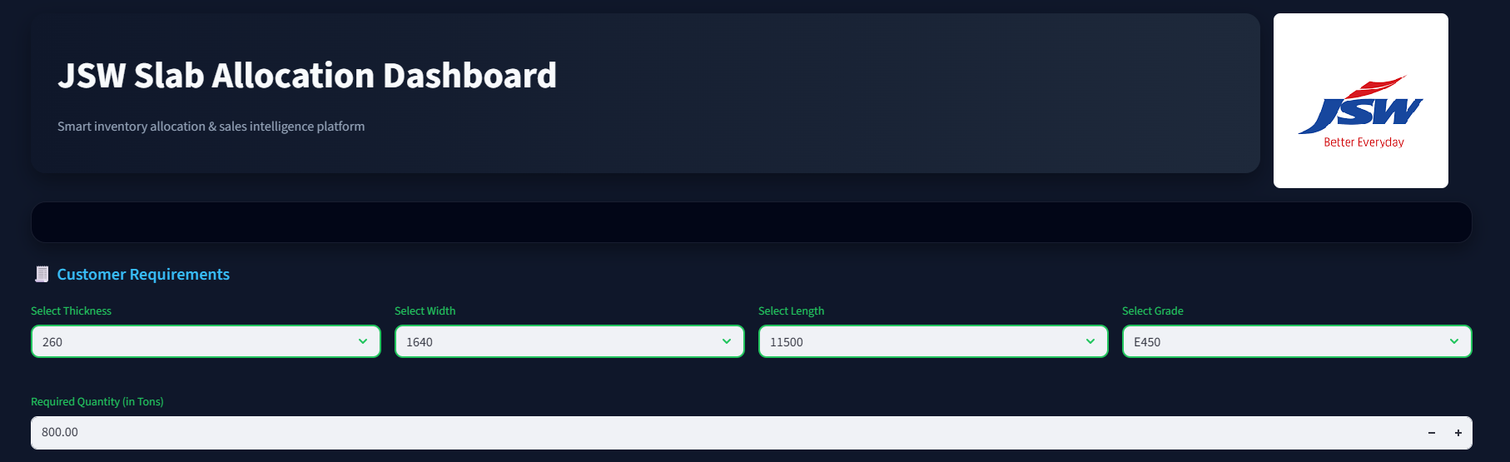

**Figure-1 Customer Input Interface**

**Figure 1** shows the main dashboard of the JSW Slab Allocation System. The interface allows users to enter customer requirements by selecting slab parameters such as thickness, width, length, grade, and required quantity in tons. All input fields are highlighted to ensure clarity and accuracy during data entry. The dashboard layout is intuitive, enabling users to easily understand the allocation rules before executing the allocation process.

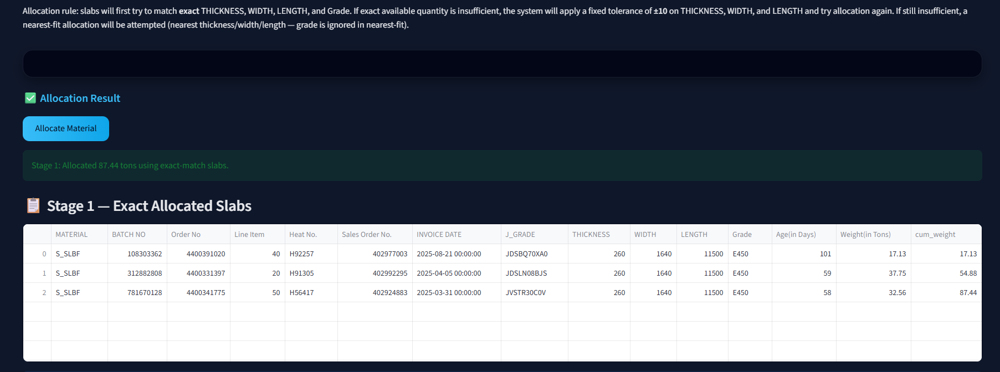

**Figure-2 Exact Match Allocation**

**Figure 2** illustrates the results of **Stage 1: Exact Allocation**. In this stage, the system identifies slabs that exactly match the customer-specified thickness, width, length, and grade. The allocated slabs are displayed in a tabular format along with detailed attributes such as batch number, order number, invoice date, slab dimensions, weight, and cumulative weight. This stage ensures maximum accuracy by prioritizing exact matches wherever available.

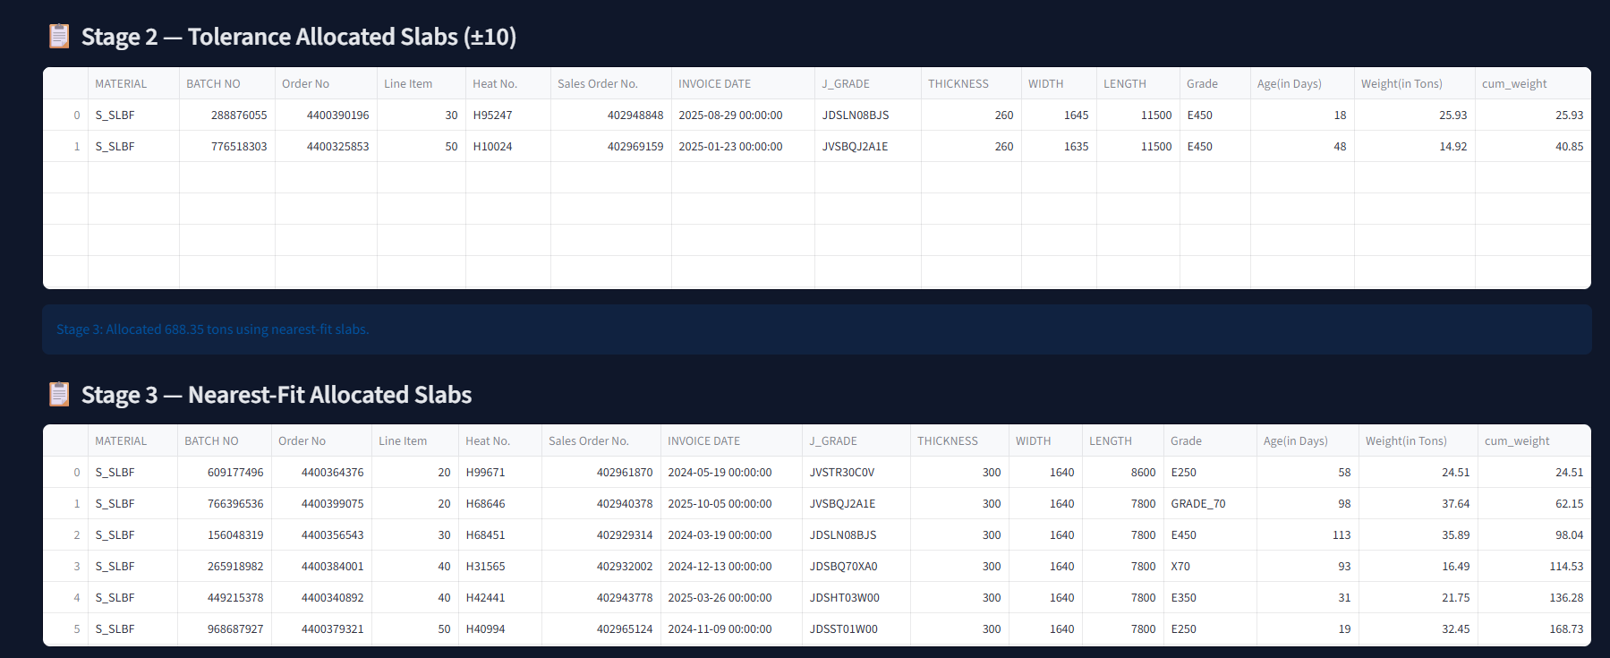

**Figure-3 Tolerance-Based Allocation**

**Figure 3** presents the **Stage 2: Tolerance Allocation** results. When exact matching slabs are insufficient to meet the required quantity, the system applies a fixed tolerance of ±10 units on thickness, width, and length while maintaining the same grade. The table clearly displays the slabs selected within the tolerance range along with their weights and cumulative allocation. This stage improves inventory utilization while still adhering closely to customer specifications.

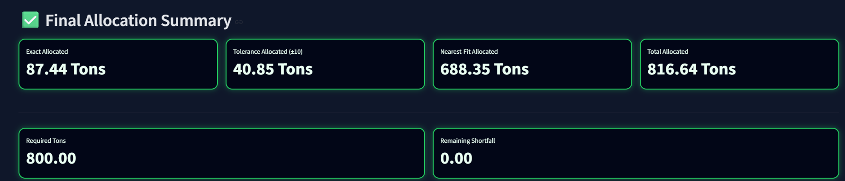

**Figure-4: Final Allocation Summary**

**Figure 4** displays the **Final Allocation Summary** of the system. Key performance indicators such as Exactly Allocated, Tolerance Allocated, Nearest-Fit Allocated, Total Allocated, Required Tons, and Remaining Shortfall are highlighted prominently. From the results, it is observed that the total required quantity of **800 tons** was successfully allocated with **zero shortfall,** demonstrating the effectiveness of the staged allocation strategy.

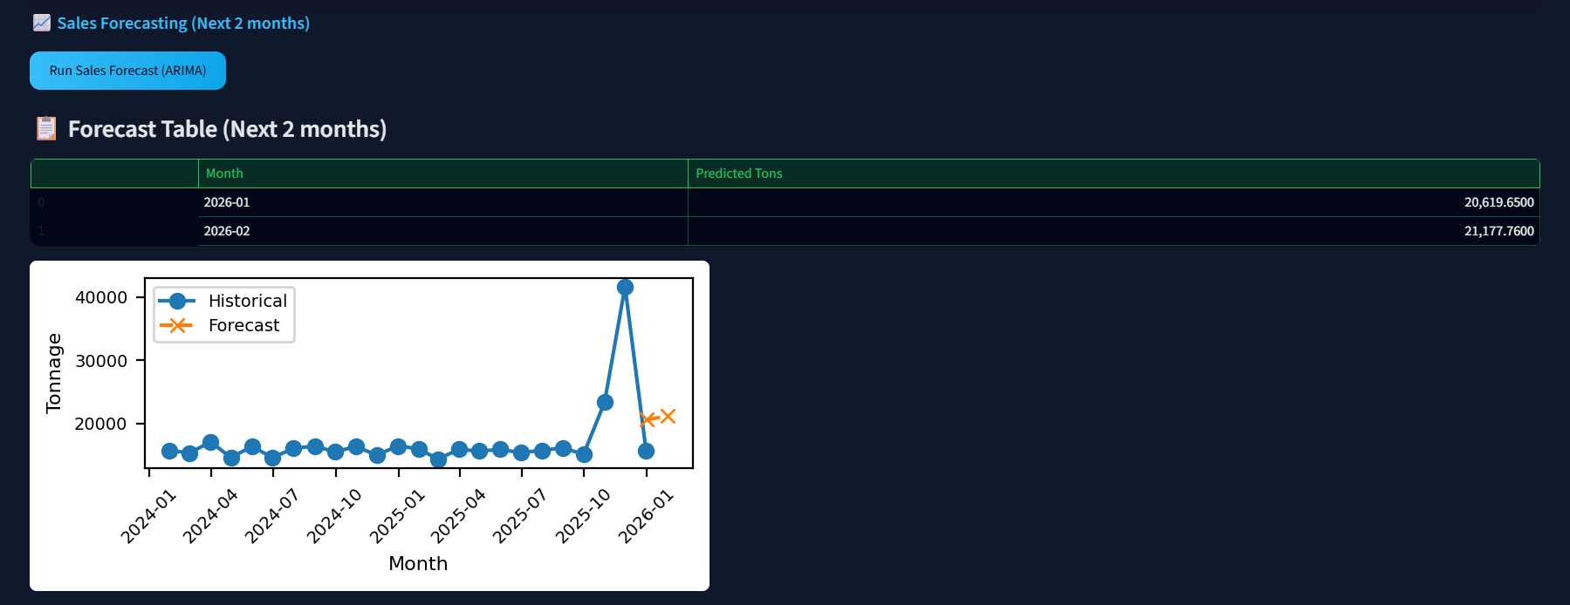

**Figure-5: Sales Forecasting Results**

**Figure 5** illustrates the **Sales Forecasting Module** of the application. Using historical sales data, the system predicts sales for the next two months using the ARIMA time series model. The forecasted values are displayed in both tabular and graphical formats, allowing users to visualize trends and expected demand. The forecasting feature supports production planning and inventory management by providing short-term predictive insights.

## 5. CONCLUSION

The internship at **JSW Steel Ltd., Dolvi Works** was a highly valuable and enriching experience that contributed significantly to my academic and professional development. The key outcomes of the internship are summarized below:

* **Practical Exposure:**  
    
  Gained hands-on experience in working with real industrial data and understanding how IT systems support large-scale manufacturing operations.
* **Application of Theoretical Knowledge:**  
  Successfully applied concepts from computer engineering courses such as programming, data analysis, databases, and basic machine learning to solve a real-world problem.
* **Project Accomplishment:**  
  Designed and developed the *JSW Slab Allocation System*, which automated slab allocation using exact, tolerance-based, and nearest-fit logic, improving efficiency and reducing manual effort.
* **Analytical and Problem-Solving Skills:**  
  Enhanced ability to analyze complex problems, design logical solutions, and iteratively refine the system based on testing and feedback.
* **Professional Skill Development:**  
  Improved communication, documentation, teamwork, and time management skills through interaction with mentors and adherence to project timelines.
* **Understanding of Industrial Work Culture:**  
  Observed and adopted professional values such as discipline, accountability, and commitment to quality, which are essential for a successful engineering career.
* **Career Motivation:**  
  The internship strengthened my interest in data analytics and software development within industrial environments and motivated me to pursue further learning in these domains. Overall, the internship successfully bridged the gap between academic learning and industrial application, providing a strong foundation for my future professional career.

**6. BIBLIOGRAPHY**

|  |  |
| --- | --- |
| **Sr. No.** | **Reference** |
| **1** | Box, G. E. P., Jenkins, G. M., & Reinsel, G. C., Time Series Analysis: Forecasting and Control, Wiley, 4th Edition, 2008. |
| **2** | JSW Steel Ltd., Official Website and Annual Reports.  Available at: <https://www.jsw.in> |
| **3** | Pandas Development Team, Pandas Documentation.  Available at: <https://pandas.pydata.org/> |
| **4** | Statsmodels Development Team, Statsmodels Documentation.  Available at: <https://www.statsmodels.org/> |
| **5** | Brownlee, J., Introduction to Time Series Forecasting with Python, Machine Learning Mastery, 2018. |

1. **Plagiarism Report**

